**Week 4 Spring-Rest-Handson**

**Name: Adi Jain**

**Superset ID: 6390400**

**Hands-on 1**

**Hello World RESTful Web Service**   
  
Write a REST service in the spring learn application created earlier, that returns the text "Hello World!!" using Spring Web Framework.

**Code**

**File name: pom.xml**

<?xml version="1.0" encoding="UTF-8"?>  
<project xmlns="http://maven.apache.org/POM/4.0.0" xmlns:xsi="http://www.w3.org/2001/XMLSchema-instance"  
 xsi:schemaLocation="http://maven.apache.org/POM/4.0.0 https://maven.apache.org/xsd/maven-4.0.0.xsd">  
 <modelVersion>4.0.0</modelVersion>  
 <parent>  
 <groupId>org.springframework.boot</groupId>  
 <artifactId>spring-boot-starter-parent</artifactId>  
 <version>3.5.3</version>  
 <relativePath/> <!-- lookup parent from repository -->  
 </parent>  
 <groupId>com.cognizant</groupId>  
 <artifactId>spring-learn</artifactId>  
 <version>0.0.1-SNAPSHOT</version>  
 <name>spring-learn</name>  
 <description>Demo project for Spring Boot</description>  
 <url/>  
 <licenses>  
 <license/>  
 </licenses>  
 <developers>  
 <developer/>  
 </developers>  
 <scm>  
 <connection/>  
 <developerConnection/>  
 <tag/>  
 <url/>  
 </scm>  
 <properties>  
 <java.version>17</java.version>  
 </properties>  
 <dependencies>  
 <dependency>  
 <groupId>org.springframework.boot</groupId>  
 <artifactId>spring-boot-starter-web</artifactId>  
 </dependency>  
  
 <dependency>  
 <groupId>org.springframework.boot</groupId>  
 <artifactId>spring-boot-devtools</artifactId>  
 <scope>runtime</scope>  
 <optional>true</optional>  
 </dependency>  
 <dependency>  
 <groupId>org.springframework.boot</groupId>  
 <artifactId>spring-boot-starter-test</artifactId>  
 <scope>test</scope>  
 </dependency>  
 </dependencies>  
  
 <build>  
 <plugins>  
 <plugin>  
 <groupId>org.springframework.boot</groupId>  
 <artifactId>spring-boot-maven-plugin</artifactId>  
 </plugin>  
 </plugins>  
 </build>  
  
</project>

**========================================================**

**File Name: application.properties**

spring.application.name=spring-learn  
server.port=8083

**========================================================**

**File Name: HelloController.java**

package com.cognizant.springlearn.controller;  
  
import org.slf4j.Logger;  
import org.slf4j.LoggerFactory;  
import org.springframework.web.bind.annotation.GetMapping;  
import org.springframework.web.bind.annotation.RestController;  
  
@RestController  
public class HelloController {  
  
 private static final Logger *LOGGER* = LoggerFactory.*getLogger*(HelloController.class);  
  
 @GetMapping("/hello")  
 public String sayHello() {  
 *LOGGER*.info("START - sayHello()");  
 String message = "Hello World!!";  
 *LOGGER*.info("END - sayHello()");  
 return message;  
 }  
}

**========================================================**

**File Name: SpringLearnApplication.java**

package com.cognizant.springlearn;  
  
import org.springframework.boot.SpringApplication;  
import org.springframework.boot.autoconfigure.SpringBootApplication;  
  
@SpringBootApplication  
public class SpringLearnApplication {  
 public static void main(String[] args) {  
 SpringApplication.*run*(SpringLearnApplication.class, args);  
 }  
}

**========================================================**

**Output**

**Folder Structure**

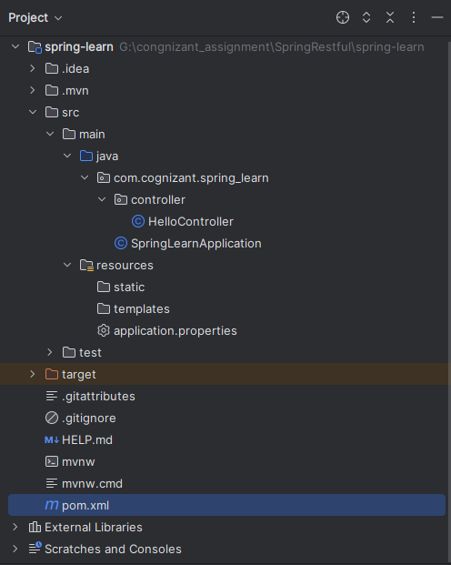

**========================================================**

**Final Output**

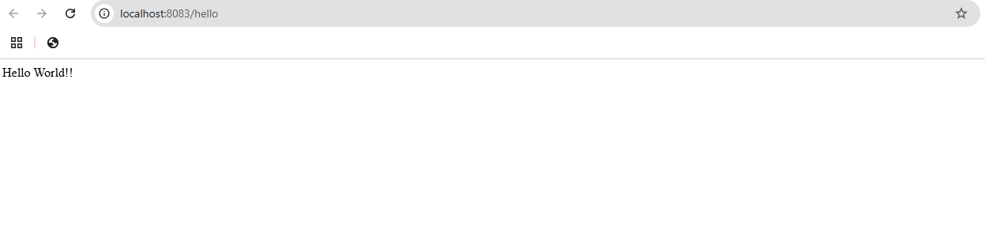

**========================================================**

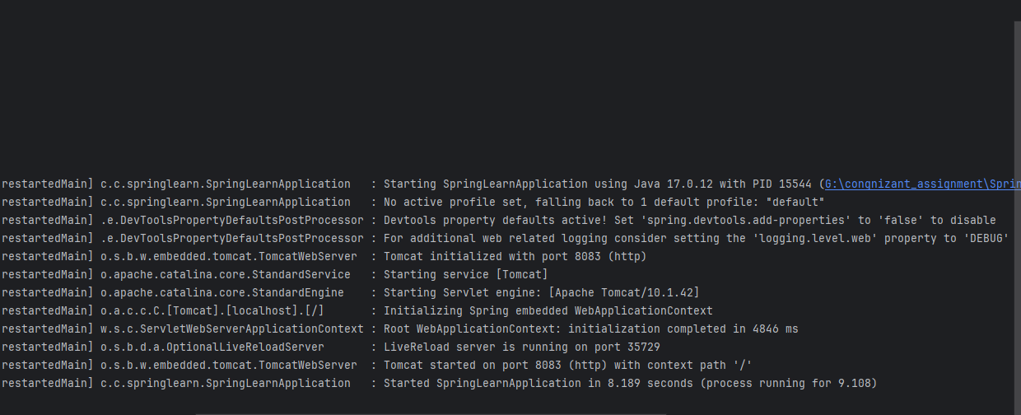

**========================================================**

**Hands-on 2**

Write a REST service that returns India country details in the earlier created spring learn application.

**Code**

**File Name: Country.java**

package com.cognizant.spring_learn.model;  
  
import java.io.Serializable;  
  
public class Country implements Serializable {  
  
 private String code;  
 private String name;  
  
 public Country() {}  
  
 public Country(String code, String name) {  
 this.code = code;  
 this.name = name;  
 }  
  
 public String getCode() {  
 return code;  
 }  
  
 public void setCode(String code) {  
 this.code = code;  
 }  
  
 public String getName() {  
 return name;  
 }  
  
 public void setName(String name) {  
 this.name = name;  
 }  
}

**========================================================**

**File Name: country.xml**

<?xml version="1.0" encoding="UTF-8"?>  
<beans xmlns="http://www.springframework.org/schema/beans"  
 xmlns:xsi="http://www.w3.org/2001/XMLSchema-instance"  
 xsi:schemaLocation="  
 http://www.springframework.org/schema/beans  
 http://www.springframework.org/schema/beans/spring-beans.xsd">  
  
 <bean id="country" class="com.cognizant.spring_learn.model.Country">  
 <property name="code" value="IN"/>  
 <property name="name" value="India"/>  
 </bean>  
  
</beans>

**========================================================**

**File Name: CountryController.java**

package com.cognizant.spring_learn.controller;  
  
import com.cognizant.spring_learn.model.Country;  
import org.slf4j.Logger;  
import org.slf4j.LoggerFactory;  
import org.springframework.context.ApplicationContext;  
import org.springframework.context.support.ClassPathXmlApplicationContext;  
import org.springframework.web.bind.annotation.RequestMapping;  
import org.springframework.web.bind.annotation.RestController;  
  
@RestController  
public class CountryController {  
  
 private static final Logger *LOGGER* = LoggerFactory.*getLogger*(CountryController.class);  
  
 @RequestMapping("/country")  
 public Country getCountryIndia() {  
 *LOGGER*.info("START - getCountryIndia()");  
 ApplicationContext context = new ClassPathXmlApplicationContext("country.xml");  
 Country country = (Country) context.getBean("country");  
 *LOGGER*.info("END - getCountryIndia()");  
 return country;  
 }  
}

**========================================================**

**File Name: application.properties**

spring.application.name=spring-learn  
server.port=8083

**========================================================**

**File Name: SpringLearnApplication.java**

package com.cognizant.spring_learn;  
  
import org.springframework.boot.SpringApplication;  
import org.springframework.boot.autoconfigure.SpringBootApplication;  
  
@SpringBootApplication  
public class SpringLearnApplication {  
 public static void main(String[] args) {  
 SpringApplication.*run*(SpringLearnApplication.class, args);  
 }  
}

**========================================================**

**Output**

**Folder Structure**

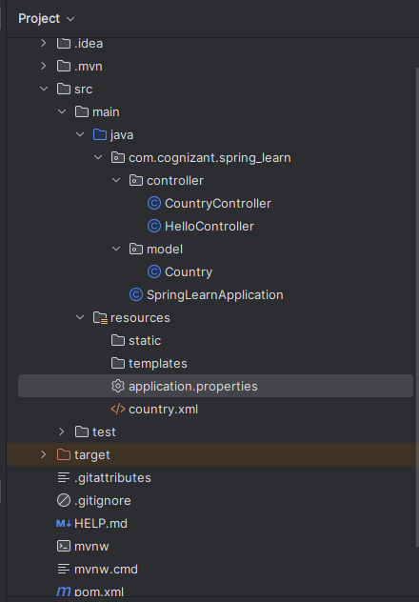

**========================================================**

**Final Output**

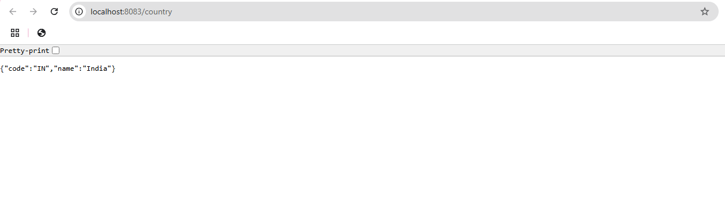

**========================================================**

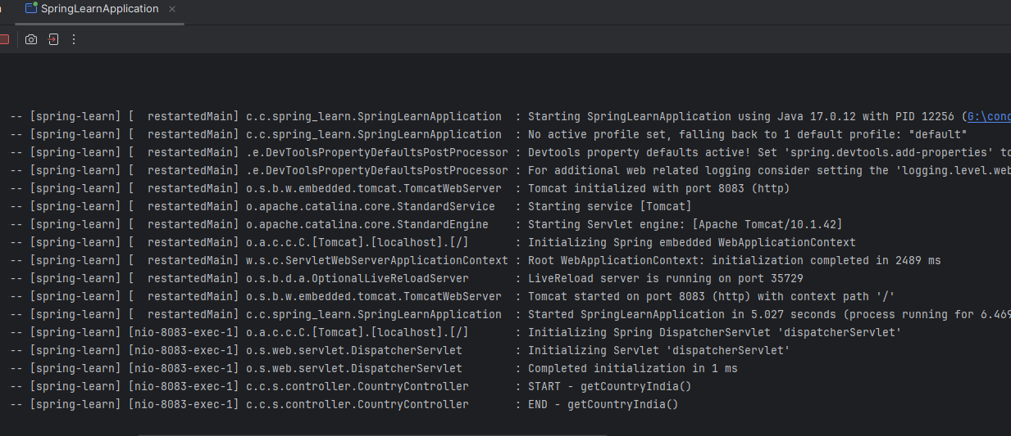

**========================================================**

**Hands-on 3**

Write a REST service that returns a specific country based on country code. The country code should be case insensitive.

**Code**

**File Name: CountryConfig.java**

package com.cognizant.spring_learn.config;  
  
import com.cognizant.spring_learn.model.CountryList;  
import jakarta.xml.bind.Unmarshaller;  
import org.springframework.context.annotation.Bean;  
import org.springframework.context.annotation.Configuration;  
  
import jakarta.xml.bind.annotation.XmlElement;  
import jakarta.xml.bind.annotation.XmlRootElement;  
import java.io.InputStream;  
import jakarta.xml.bind.JAXBContext;  
import jakarta.xml.bind.Unmarshaller;  
  
@Configuration  
public class CountryConfig {  
  
 @Bean  
 public CountryList countryList() throws Exception {  
 InputStream is = this.getClass().getResourceAsStream("/country.xml");  
 JAXBContext context = JAXBContext.*newInstance*(CountryList.class);  
 Unmarshaller unmarshaller = context.createUnmarshaller();  
 return (CountryList) unmarshaller.unmarshal(is);  
 }  
}

**========================================================**

**File Name: Country.xml**

<country-list>  
 <country>  
 <code>IN</code>  
 <name>India</name>  
 </country>  
 <country>  
 <code>US</code>  
 <name>United States</name>  
 </country>  
 <country>  
 <code>DE</code>  
 <name>Germany</name>  
 </country>  
</country-list>

**========================================================**

**File Name: CountryList.java**

package com.cognizant.spring_learn.model;  
  
//import javax.xml.bind.annotation.XmlElement;  
//import javax.xml.bind.annotation.XmlRootElement;  
import jakarta.xml.bind.JAXBContext;  
import jakarta.xml.bind.annotation.XmlElement;  
import jakarta.xml.bind.annotation.XmlRootElement;  
import java.util.List;  
  
@XmlRootElement(name = "country-list")  
public class CountryList {  
 private List<Country> countries;  
  
 @XmlElement(name = "country")  
 public List<Country> getCountries() {  
 return countries;  
 }  
  
 public void setCountries(List<Country> countries) {  
 this.countries = countries;  
 }  
}

**========================================================**

**File Name: Country.java**

package com.cognizant.spring_learn.model;  
//import javax.xml.bind.annotation.XmlRootElement;  
import jakarta.xml.bind.JAXBContext;  
import jakarta.xml.bind.annotation.XmlRootElement;  
  
@XmlRootElement(name = "country")  
public class Country {  
 private String code;  
 private String name;  
  
 public Country() {}  
  
 public Country(String code, String name) {  
 this.code = code;  
 this.name = name;  
 }  
  
 public String getCode() {  
 return code;  
 }  
  
 public void setCode(String code) {  
 this.code = code.toUpperCase();  
 }  
  
 public String getName() {  
 return name;  
 }  
  
 public void setName(String name) {  
 this.name = name;  
 }  
}

**========================================================**

**File Name: pom.xml**

<?xml version="1.0" encoding="UTF-8"?>  
<project xmlns="http://maven.apache.org/POM/4.0.0" xmlns:xsi="http://www.w3.org/2001/XMLSchema-instance"  
 xsi:schemaLocation="http://maven.apache.org/POM/4.0.0 https://maven.apache.org/xsd/maven-4.0.0.xsd">  
 <modelVersion>4.0.0</modelVersion>  
 <parent>  
 <groupId>org.springframework.boot</groupId>  
 <artifactId>spring-boot-starter-parent</artifactId>  
 <version>3.5.3</version>  
 <relativePath/> <!-- lookup parent from repository -->  
 </parent>  
 <groupId>com.cognizant</groupId>  
 <artifactId>spring-learn</artifactId>  
 <version>0.0.1-SNAPSHOT</version>  
 <name>spring-learn</name>  
 <description>Demo project for Spring Boot</description>  
 <url/>  
 <licenses>  
 <license/>  
 </licenses>  
 <developers>  
 <developer/>  
 </developers>  
 <scm>  
 <connection/>  
 <developerConnection/>  
 <tag/>  
 <url/>  
 </scm>  
 <properties>  
 <java.version>17</java.version>  
 </properties>  
 <dependencies>  
 <dependency>  
 <groupId>org.springframework.boot</groupId>  
 <artifactId>spring-boot-starter-web</artifactId>  
 </dependency>  
  
 <dependency>  
 <groupId>org.springframework.boot</groupId>  
 <artifactId>spring-boot-devtools</artifactId>  
 <scope>runtime</scope>  
 <optional>true</optional>  
 </dependency>  
 <dependency>  
 <groupId>org.springframework.boot</groupId>  
 <artifactId>spring-boot-starter-test</artifactId>  
 <scope>test</scope>  
 </dependency>  
 <!-- JAXB API -->  
 <dependency>  
 <groupId>jakarta.xml.bind</groupId>  
 <artifactId>jakarta.xml.bind-api</artifactId>  
 <version>4.0.0</version>  
 </dependency>  
  
 <!-- JAXB Runtime (implementation) -->  
 <dependency>  
 <groupId>org.glassfish.jaxb</groupId>  
 <artifactId>jaxb-runtime</artifactId>  
 <version>4.0.3</version>  
 </dependency>  
 </dependencies>  
  
 <build>  
 <plugins>  
 <plugin>  
 <groupId>org.springframework.boot</groupId>  
 <artifactId>spring-boot-maven-plugin</artifactId>  
 </plugin>  
 </plugins>  
 </build>  
  
</project>

**========================================================**

**File Name: CountryService.java**

package com.cognizant.spring_learn.service;  
  
import com.cognizant.spring_learn.model.Country;  
import com.cognizant.spring_learn.model.CountryList;  
import org.springframework.beans.factory.annotation.Autowired;  
import org.springframework.stereotype.Service;  
  
@Service  
public class CountryService {  
  
 @Autowired  
 private CountryList countryList;  
  
 public Country getCountry(String code) throws Exception {  
 return countryList.getCountries().stream()  
 .filter(c -> c.getCode().equalsIgnoreCase(code))  
 .findFirst()  
 .orElseThrow(() -> new Exception("Country not found"));  
 }  
}

**========================================================**

**File Name: HelloController.java**

package com.cognizant.springlearn.controller;  
  
import org.slf4j.Logger;  
import org.slf4j.LoggerFactory;  
import org.springframework.web.bind.annotation.GetMapping;  
import org.springframework.web.bind.annotation.RestController;  
  
@RestController  
public class HelloController {  
  
 private static final Logger *LOGGER* = LoggerFactory.*getLogger*(HelloController.class);  
  
 @GetMapping("/hello")  
 public String sayHello() {  
 *LOGGER*.info("START - sayHello()");  
 String message = "Hello World!!";  
 *LOGGER*.info("END - sayHello()");  
 return message;  
 }  
}

**========================================================**

**File Name: CountryController.java**

package com.cognizant.spring_learn.controller;  
  
import com.cognizant.spring_learn.model.Country;  
import com.cognizant.spring_learn.service.CountryService;  
import org.springframework.beans.factory.annotation.Autowired;  
import org.springframework.web.bind.annotation.*;  
  
@RestController  
public class CountryController {  
  
 @Autowired  
 private CountryService countryService;  
  
 @GetMapping("/countries/{code}")  
 public Country getCountry(@PathVariable String code) throws Exception {  
 return countryService.getCountry(code);  
 }  
}

**========================================================**

**File Name: application.properties**

spring.application.name=spring-learn  
server.port=8083

**========================================================**

**File Name: SpringLearnApplication.java**

package com.cognizant.spring_learn;  
  
import org.springframework.boot.SpringApplication;  
import org.springframework.boot.autoconfigure.SpringBootApplication;  
  
@SpringBootApplication  
public class SpringLearnApplication {  
 public static void main(String[] args) {  
 SpringApplication.*run*(SpringLearnApplication.class, args);  
 }  
}

**========================================================**

**Output**

**Folder Structure**

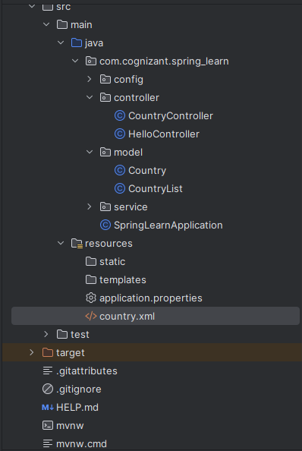

**========================================================**

**Final Output**



